URL: http://www.lgnewsroom.com/2021/02/lg-expands-webos-smart-tv-platform-to-tv-brand-partners
February 24, 2021

LG Expands webOS Smart TV Platform to TV Brand Partners

LG Opens Popular Platform and Integrated Content Services to
Manufacturers to Deliver Better TV Experience to Even More Consumers
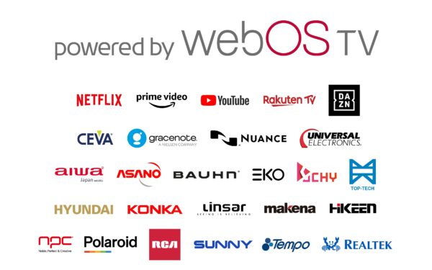
SEOUL, Feb. 24, 2021 — LG Electronics (LG) announces the availability of its popular webOS TV platform ecosystem to other TV brand partners, disrupting the status quo in an industry known for its proprietary operating systems across different manufacturers. LG is now expanding its expertise beyond TV manufacturing to encompass webOS TV software platform development and adoption by other TV brands. This has the potential to reshape the TV business for both technology and content providers while significantly growing LG’s presence and prominence in the global home entertainment market.
As an integral component of LG’s preeminent home entertainment ecosystem, webOS has delivered exceptional ease of use for LG TV owners through its intuitive interface design since 2014. Licensees of webOS TV receive the familiar and highly acclaimed UX design along with a rich pool of features such as voice search and control, integrated AI algorithms and easy connectivity that have earned webOS positive industry and consumer accolades. With LG webOS TV, partners also get a diversity of content options including access to global streaming service apps such as Netflix, YouTube, Amazon Prime Video and sports streaming service DAZN as well as LG Channels, the company’s free premium content streaming service.* Compatible TV models also include the dedicated Magic Motion remote controller.
Over twenty TV manufacturers from around the world have already committed to the webOS partnership, including brands such as RCA, Ayonz and Konka with more partners expected to join in the future. The webOS ecosystem is supported by technology partners such as Realtek, Nuance, Gracenote, CEVA and Universal Electronics, among many others.
“The webOS platform is one of the easiest and most convenient way to access millions of hours of movies and TV shows,” said Park Hyoung-sei, president of the LG Home Entertainment Company. “By welcoming other manufacturers to join the webOS TV ecosystem, we are embarking on a new path that allows many new TV owners to experience the same great UX and features that are available on LG TVs. We look forward to bringing these new customers into the incredible world of webOS TV.”
# # #
* Content app availability vary by region.

