url: https://www.lgnewsroom.com/2022/10/lg-advances-its-smart-tv-platform-business-with-webos-hub/

October 6, 2022

LG Advances Its Smart TV Platform Business With webOS Hub
- Open share list
New Upgrade Offers a Customizable Interface for TV Brand Partners,
More Content and Convenience for Users
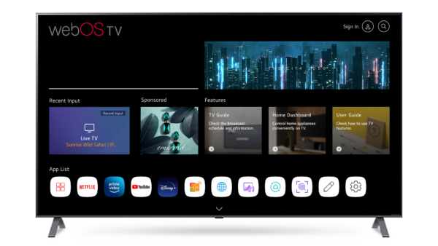
SEOUL, Oct. 6, 2022 — LG Electronics (LG) has expanded its smart TV platform business with the recent rolling out of its webOS Hub, an upgraded version of its webOS solution for third-party partners. Delivering more customization options to smart TV makers and more convenience and content to end-users, webOS Hub will be available to an expanded network of 200 partner brands including Seiki, Eko, Stream System, Konka, Aiwa and Hyundai – a ten-fold increase from when LG commenced licensing its webOS ecosystem in early 2021.
More than just a smart platform, webOS Hub comes with support from LG’s technology partners, such as Dolby, Realtek, Gracenote and CEVA, and has been certified by more than 160 broadcasters from around the globe. The new upgrade further demonstrates the company’s commitment to extending the ultimate user experience to more consumers worldwide.
webOS Hub makes it possible for brands to customize the user interface (UI) in a variety of ways, such as fine-tuning the Home screen by selecting the color scheme, applying a visual style consistent with their identity or inserting a logo for visibility. By providing the capability to tailor webOS Hub, LG is enabling smart TV manufacturers to differentiate their offerings while delivering a more expansive and enjoyable user experience.
With enhanced usability and personalization features, webOS Hub provides users with a curated selection of content to check out based on their tastes and preferences. A real time-saver, Next Pick¹ recommends up to three live programs, from broadcast stations or a connected set-top box, as well as one VOD title or app. Additionally, the new update supports LG’s Magic Explorer, which displays information relevant to the content being played, such as actor bios and filming locations.
webOS Hub also provides an improved viewing experience with Clear Voice PRO, a feature that makes onscreen dialogue much easier to hear. As with its predecessor, webOS Hub carries major content streaming services such as Netflix, Disney+, Prime Video and LG’s free, premium content service, LG Channels. Joining these are new streaming services such as Fubo TV, with popular cloud gaming service like NVIDIA GeForce NOW to be added as well.
Along with access to a diverse range of high-quality content, LG’s comprehensive solution for smart TVs presents an array of cutting-edge features, such as advanced picture processing, variable refresh rate (VRR) support² and the Game Optimizer, which offers finetuned picture and audio settings for different game genres. The first webOS Hub-powered OLED TVs from LG’s partner TV brands will be launching soon, providing more users with the outstanding features and value already familiar to LG customers worldwide.
“We are committed to refining and expanding our webOS Hub ecosystem, which continues to introduce more and more consumers to the unparalleled user experience of LG webOS,” said Park Hyoung-sei, president of the LG Home Entertainment Company.
Over 120 million devices in 150 countries are now powered by webOS – a number that is set to grow with the availability of the new and improved webOS Hub.
# # #
¹ Functionality varies by country.
² Supported on OLED TV models.

